Some Principles of Data Ops App Development – A Blog Series

Introduction

Started reading a comforting book this week called Practical DataOps Delivering Agile Data Science at Scale by Harvinder Atwal. The author introduces the book with a good understanding of the problem of the fact that the promise of data science is often a lot greater than the actual practical implementation.

So I think I would like LogicScience Limited to be offering data apps for customers as a service so I’m beginning from scratch working out what that would involve. I’ve decided to start organically building something for myself to determine the lifecycle of a pure data driven app that serves some data science or data operations purpose and I’m starting small to begin with.

One of the things I am interested in personally is running and I’ve signed myself up for a marathon 6 months from now so in the interim I’m going to need to get fitter and in doing so I’ll need to keep myself motivated. Motivation might come from seeing my progress weekly so there is the data source. Let’s choose km per week and average pace per km weekly.

I’ll need a recording device to collect the data. For that I’ll be using a Garmin HR+ GPS watch.

Now I need to program an app or pipeline for the data to get from the Garmin to be presented in the most impactful way that shows progress towards the specific goal of becoming marathon fit. I’ve got the Garmin, connected with Strava which does it’s own analysis of GPS data and presents it in it’s own way on the website. However that’s not the way I’d like to see it. I want to record 5k runs and any distance beyond 5k. I want to know the split time for each of the first 5 km then the time for any additional distance above 5k. I want to calculate the average pace per km of the first 5km.
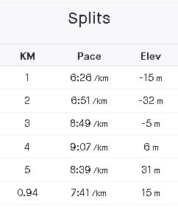
Ideally I’d like to automatically get the data from my Garmin watch or the Garmin website, since it automatically syncs online, process it and present it all automatically. However, working to devops principles and wanting to see a product I decide to knock something up more quickly. That involved writing a quick Python script to take manual data entry of the metrics of each run as they are displayed on the Strava site, for example :

This, for each run along with the date of each run is really all I need. All the other calculations will be performed within the app.

So I created a github repository for the script and the powerBI file that I’m using for presentation and also the csv file that am using as the data storage.
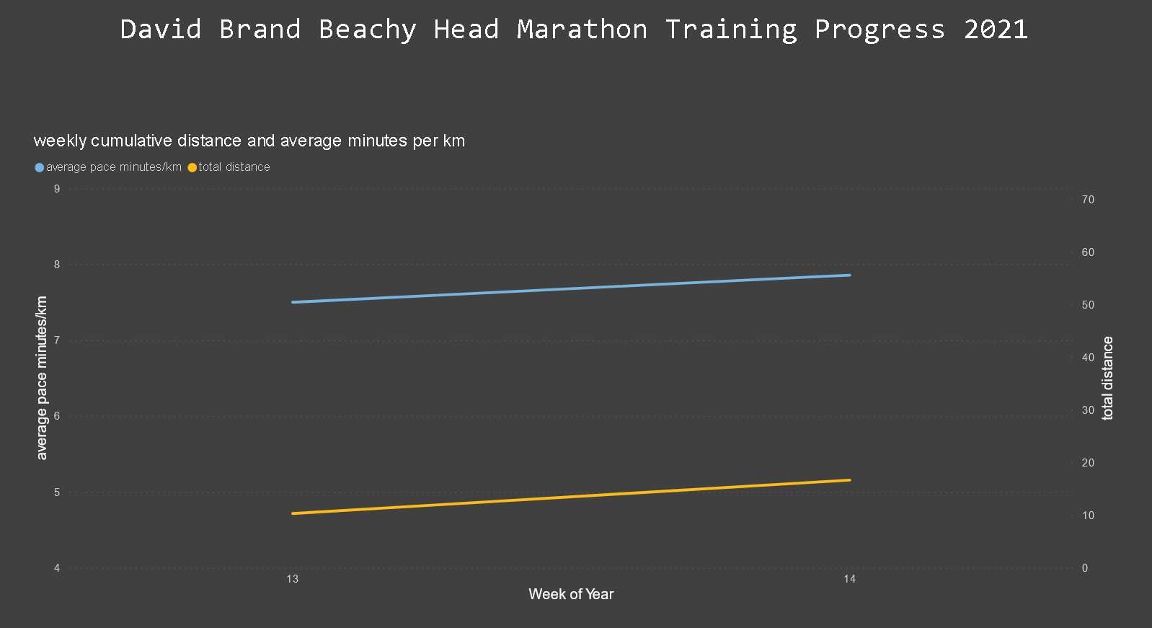

All very rudimentary at the moment but effective for the purpose. What I need to extract from the completion of this task and the continued devops cycle that will develop the app along with my training and improving fitness is to extract the key points that are required for a data project along with documenting the specific tools, code and technologies used along the way.

One notable thing that didn’t work which would have been a nice to have at this stage is powerBI connector to github which is currently in beta failed to connect to the csv stored there so instead it is hooked to the file on my local computer. Now of course the local copy is likely to be the most up to date but if that had worked I would have probably looked at automating the github push.

Anyway all this is not ideal yet. PowerBI while being a really good data analysis and visualisation tool that I use extensively is difficult to share without licencing so as a personal project I’m going to want to have a public URL for the progress. That might be something done in R probably, or perhaps Google tools. Also the data cannot be stored locally, I’ll have to work out a cloud solution which going by my current technical interests will perhaps be a noSQL database in Azure or AWS. Therefore the app will have to be updated so the script is writing directly to the cloud database. Or, which I haven’t investigated yet if it even exists, an API connection to Garmin.

Principles Learned :
- Work out data formats from the beginning. What format are dates going to be entered and stored, will that format be recognised consistently as the data flows through the pipleline by different technology that processes it, will you have to reformat it at intervals.
- Try to code calculations early so the output of the app going into storage is the data that is required in it’s final form. In that way, all transformations are done in one place at the source.

